task on ec2
- Launch one EC2 using Amazon Linux 2 image and add a script in user data to install Apache.
first created instance in ec2
provided the new keypair name
written script
#!/bin/bash
sudo yum update -y
sudo yum install httpd -y
sudo systemctl start httpd
sudo systemctl enable httpd

to install httpd and run in user data
added permissions in security group and gave port number http to port to 80 and launched instance
copying the public id and pasted in browser
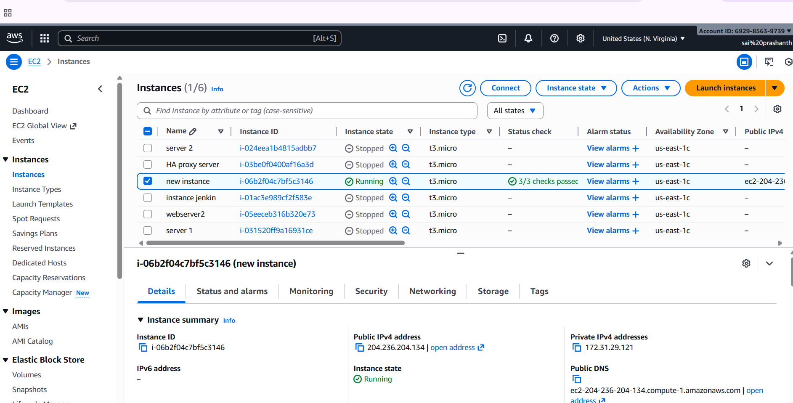
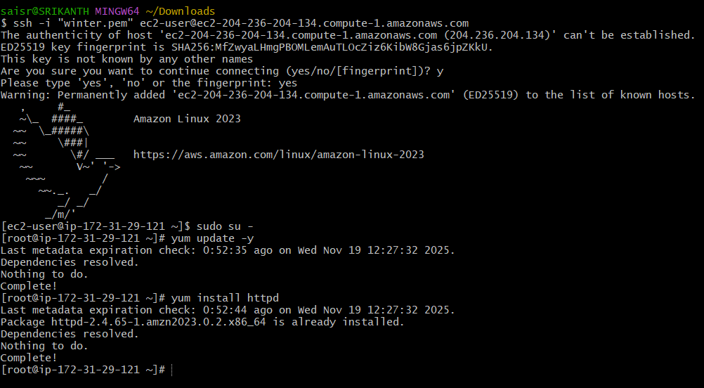
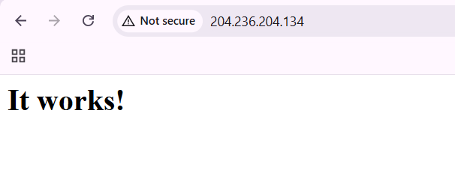
- Launch one EC2 using Ubuntu image and add a script in user data to install Nginx.
first created instance in ec2
then chosen AMI ubuntu version
written the script in user add field
#!/bin/bash
sudp apt update -y
sudo apt install nginx -y
systemctl start nginx
systemctl enable nginx
give network settings port number to 80 and save rules
check in browser with public id
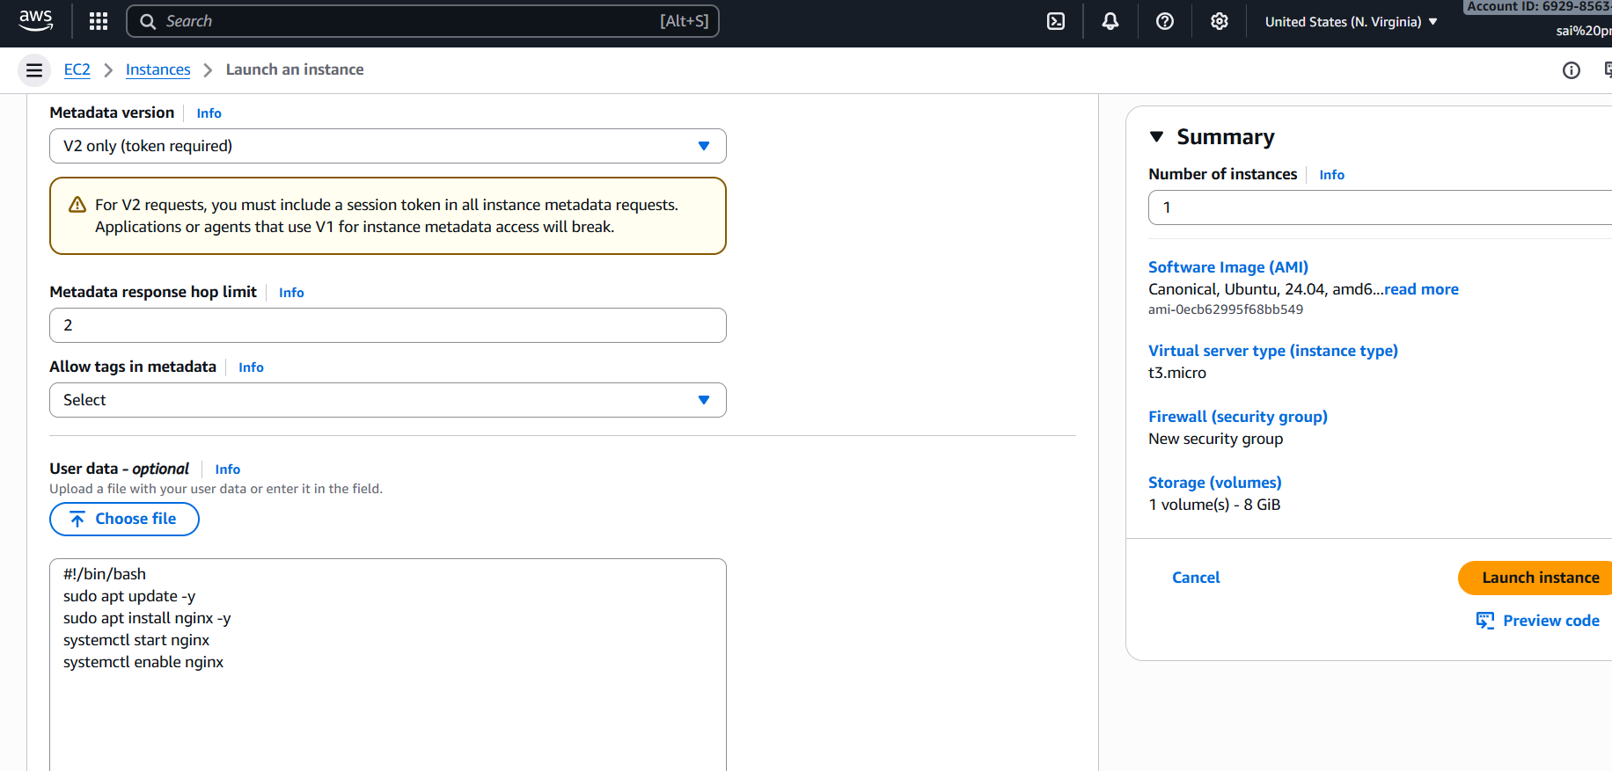

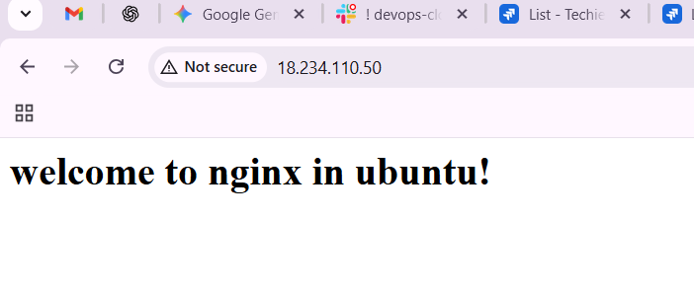
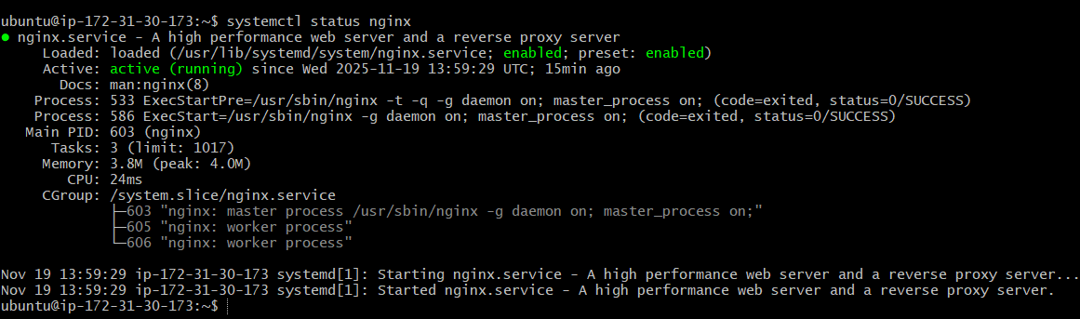
- Launch one Windows server and install Tomcat on Windows
first create instance in ec2 by adding AMI for windows
after instance go to the connect and click on RDP client button
download the RDP file and click on get password
click on upload .pem key file and you content to get the password
now open your windows server
download java jdk and install apche tomcat’
add permissions in environmental
and now run as localhost:8080
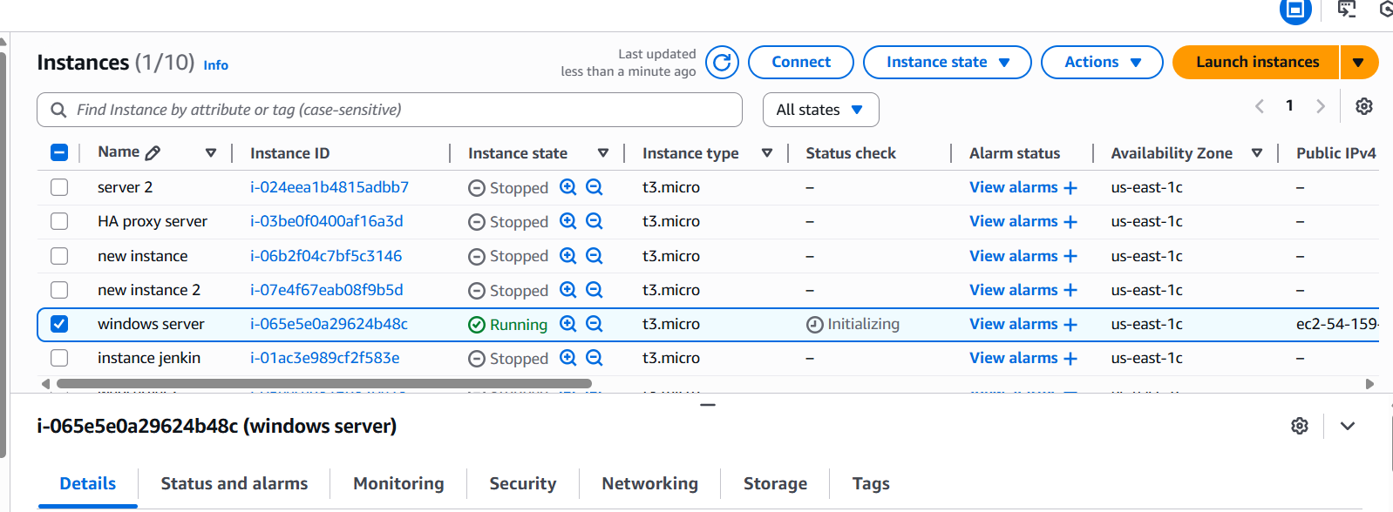
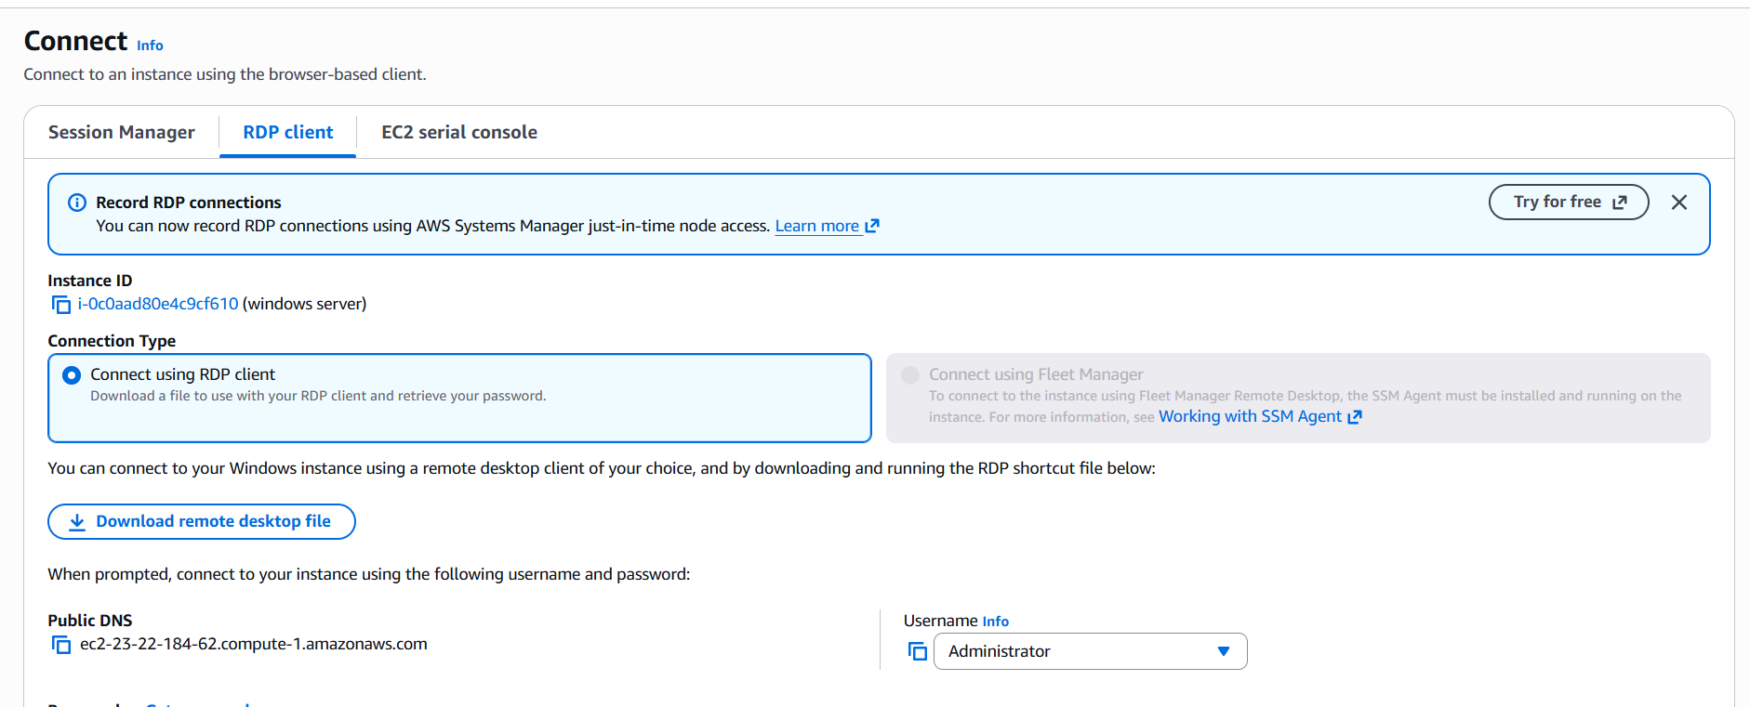
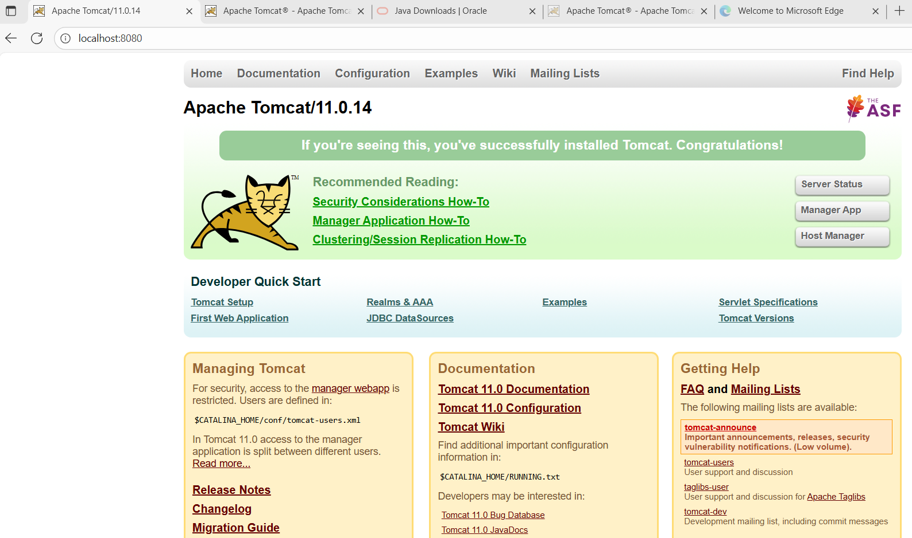
- Take a snapshot of the instance created in Task 1.
first go to instance which you created for task 1
then go to actions—image and templates—create image
give image name and description
then click on create you will get one AMI pop up
then the task has been executed

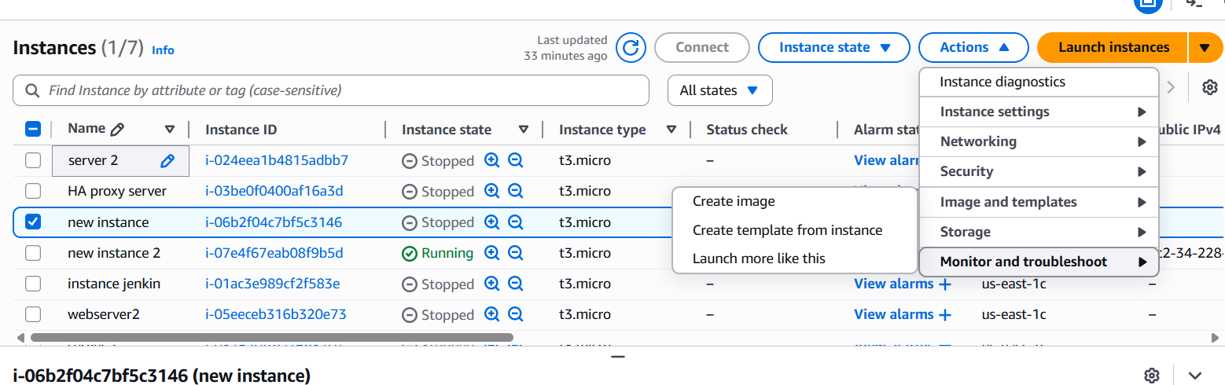
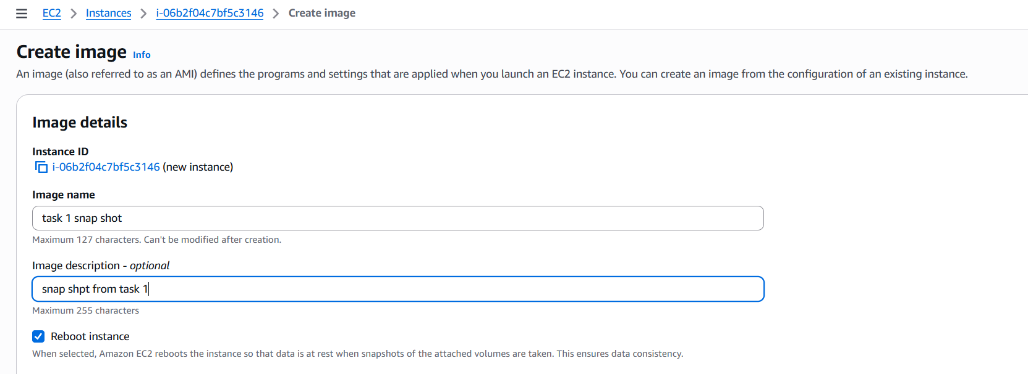
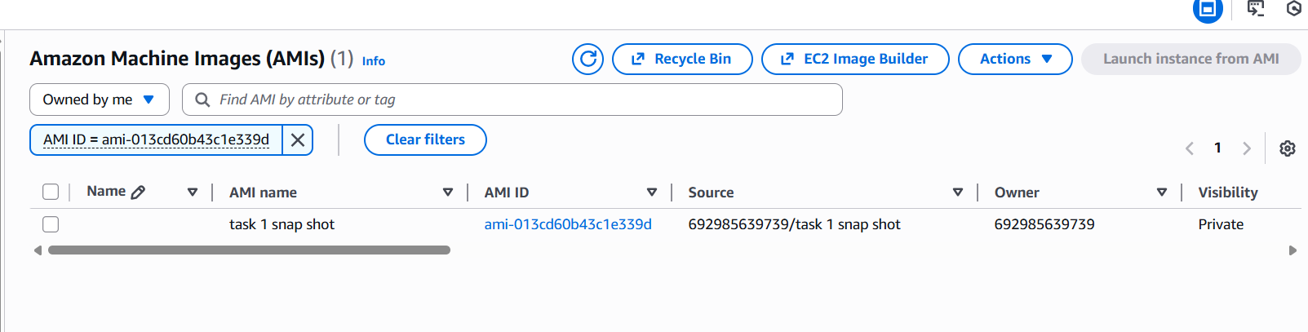
- Assign password less authentication for the EC2 created in Task 2.
first we need to do ssh-keygen
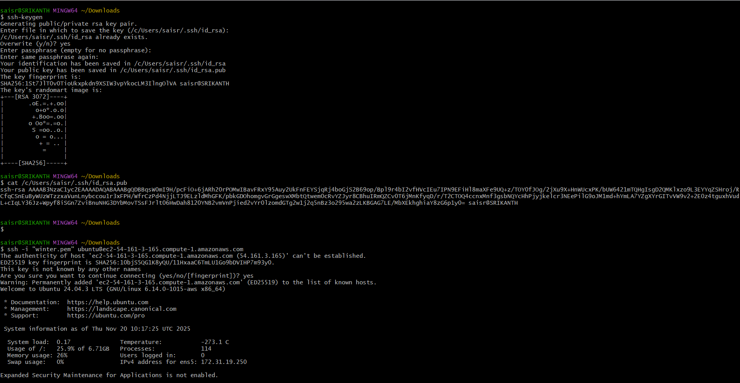
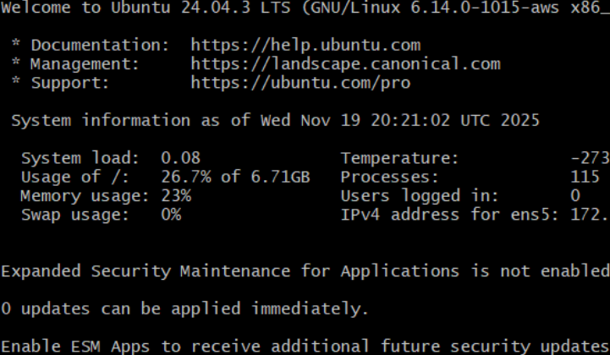

- Launch any EC2 using the spot purchasing option.
first create a instance
select any AMI and instance type t2/t3
go to advanced settings –purchasing options—request spot instance—maximum price select no –stop request type -persistent—interruption behavior-select stop and launch instance
check in ec2 dashboard-- spot requests-- you can see status
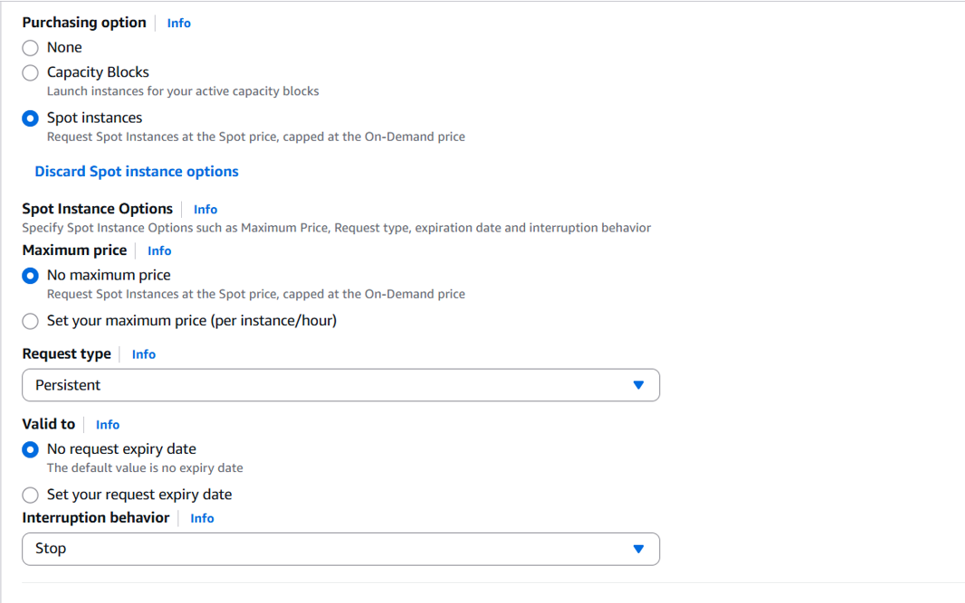
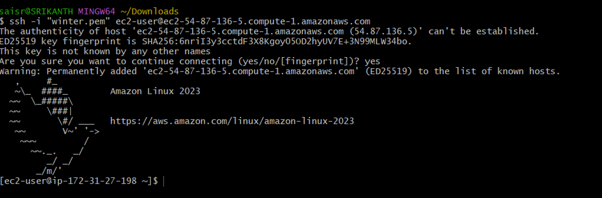
- Enable termination policy on the EC2 created in Task 2.
first open the instance created in task 2
then go to actions—instant settings—change termination protection
then you need to enable and save

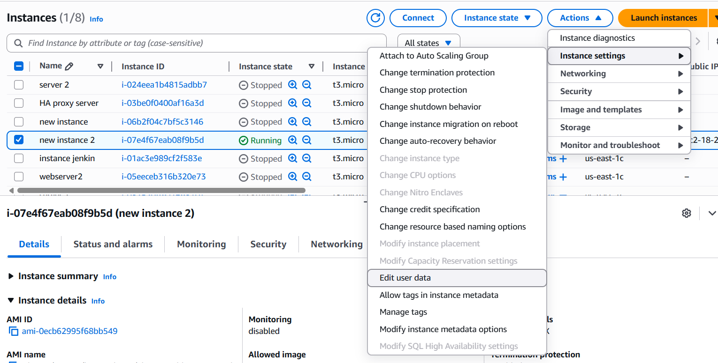
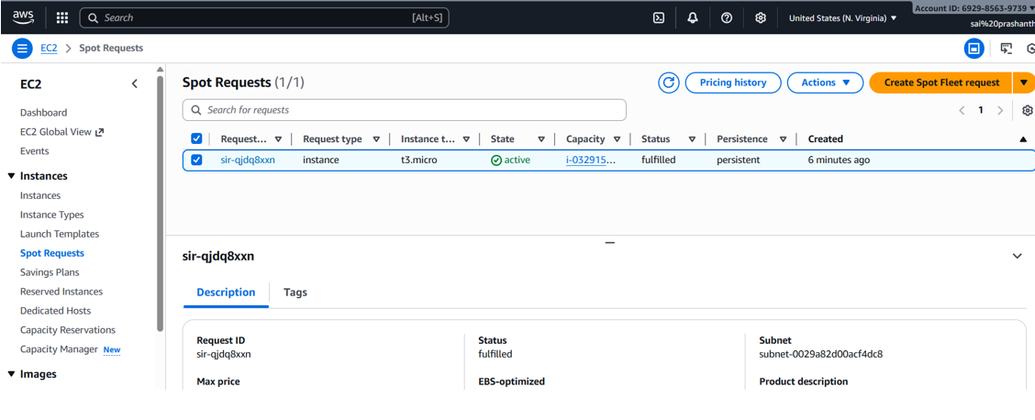

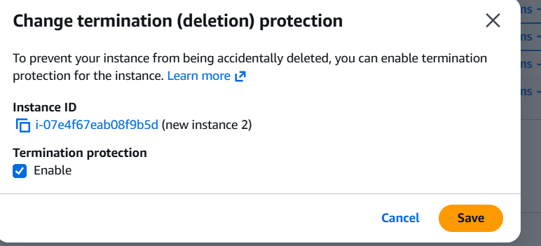
- Launch one EC2 using AWS CLI.
create the access key and secret key
save it
now configure the aws in git bash as aws configure
go to AMI catalog and copy the image id
now create the security group id and subnet id
now write the script
$ aws ec2 run-instances \
> --region us-east-1 \
> --image-id ami-0fa3fa7920f60e \
> --instance-type t3.micro \
> --key-name winter \
> --security-group-ids sg-094583e845aaf7c77 \
> --subnet-id subnet-00fd1a4de18a069e5 \
> --count 1
and execute the script in gitbash
